Pedro Bandeira is a Brazilian author known for writing popular books for children and young readers. He was born in Santos in 1942. Before becoming a full-time writer, he worked as an actor, journalist, and advertiser. He became famous for adventure and mystery books that encourage young people to enjoy reading. Some of his best-known works include is the “Os Karas” series. His books are widely used in schools across Brazil. All Pedro Bandeira books are $28.00
Favorite and Timeless Brazilian Authors

Monteiro Lobato (1882–1948) was one of Brazil’s most influential children’s authors and publishers. He is best known for creating the Sítio do Picapau Amarelo series, which blended Brazilian folklore, adventure, science, and imagination for young readers. His books helped shape modern Brazilian children’s literature and remain widely read in schools today.

Some of Lobato’s works contain racial stereotypes and language that are considered inappropriate by modern standards. Because of this, this list is carefully curated to only include those books with timeless stories.
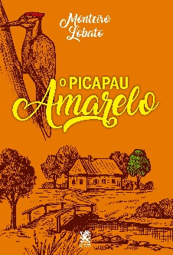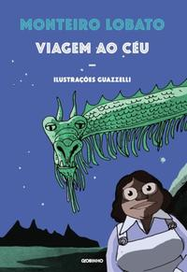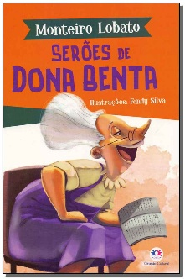
$7.00 $22.93 $8.00
Ana Maria Machado
One of Brazil’s most internationally respected children’s writers and winner of the Hans Christian Andersen Award.

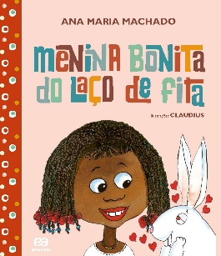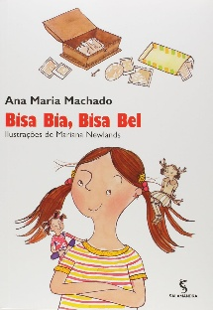
$23.85
$23.85

Ziraldo (1932–2024) was one of Brazil’s most beloved children’s authors, cartoonists, and illustrators. Born in the city of Caratinga, he became famous for creating humorous, imaginative stories that captured the voice and energy of childhood. Before writing children’s books, Ziraldo worked as a journalist, comic artist, and political cartoonist, and he helped shape modern Brazilian comics and publishing.
He is most famous for the book O Menino Maluquinho (“The Nutty Boy”), published in 1980. The story’s playful main character became a cultural icon in Brazil and inspired movies, television programs, comics, and school activities. Ziraldo’s books are known for their humor, expressive illustrations, emotional warmth, and respect for children’s creativity and independence.
Ziraldo is important because he helped modernize Brazilian children’s literature. His work moved away from overly formal moral lessons and instead celebrated imagination, curiosity, friendship, and the real experiences of children. His books remain widely used in Brazilian schools and are considered essential classics of Brazilian childhood and literacy culture.

The most beloved and influential books by Ziraldo are usually considered these classics:
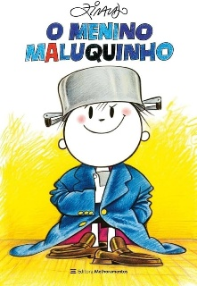
O Menino Maluquinho
His most famous work. A funny, energetic story about childhood, imagination, and growing up. It became a major cultural phenomenon in Brazil with films, TV shows, and comics. $13.10

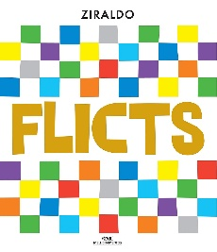
Flicts
A poetic picture book about a lonely color searching for where it belongs. It is considered one of the great masterpieces of Brazilian children’s literature. $14.50

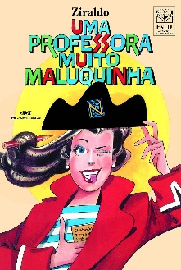
Uma Professora Muito Maluquinha
A warm and humorous story about an unconventional teacher who inspires her students. Very popular in Brazilian schools. $15.75

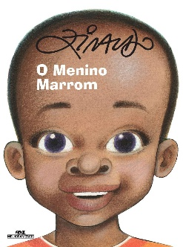
O Menino Marrom
A thoughtful story about friendship, race, and childhood curiosity, often used in classroom discussions. $12.75

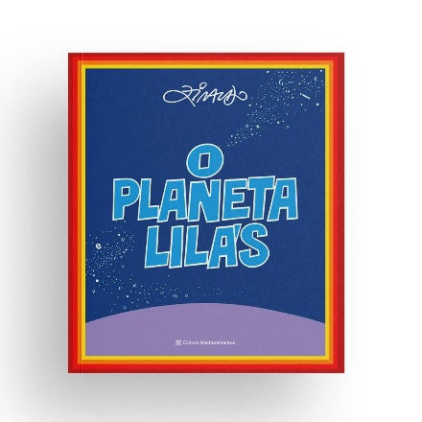.
O Planeta Lilás
A fantasy story with themes about greed, imagination, and society. $13.85

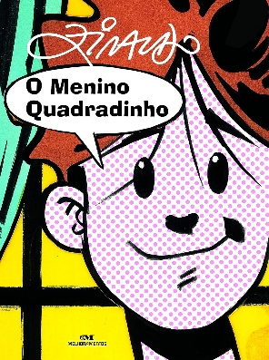
O Menino Quadradinho
A visually creative celebration of books, comics, and reading itself. $11.50

[Grab your reader’s attention with a great quote from the document or use this space to emphasize a key point. To place this text box anywhere on the page, just drag it.]
Ruth Rocha is one of Brazil’s most important children’s authors and a major figure in Brazilian education and literacy. Born in São Paulo in 1931, she worked as a sociologist and educator before becoming a writer. Beginning in the 1970s, she helped transform children’s literature in Brazil by creating stories that respected children’s intelligence, curiosity, and emotions.
Ruth Rocha became famous for books such as Marcelo, Marmelo, Martelo and O Reizinho Mandão, which combine humor, creativity, and social themes in language that is accessible to young readers. Her works are widely used in Brazilian schools because they encourage imagination, critical thinking, and discussion about fairness, language, and citizenship.
Her books helped shape generations of readers and modernized Brazilian children’s literature, making it more playful, thoughtful, and connected to children’s real experiences.

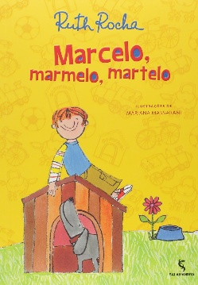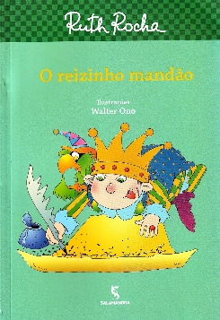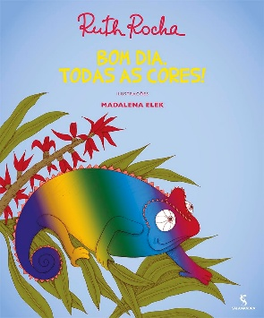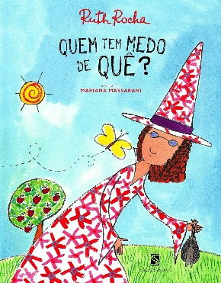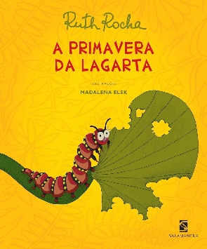
$25.75 $25.75 $25.75 $22.00 $22.00
Eva Furnari is a Brazilian writer and illustrator born in Rome, Italy, in 1948 who later moved to Brazil as a child. She became one of the country’s most recognizable creators of children’s books through her imaginative drawings, visual humor, and inventive storytelling style.
Eva Furnari first gained attention with comic strips and illustration work before publishing books that delighted young readers with playful nonsense, unusual characters, and creative wordplay. Many of her stories rely on visual storytelling, making them especially appealing to beginning readers and children developing imagination and literacy skills.
She expanded the artistic possibilities of Brazilian children’s literature and helped make illustrated books a central part of childhood reading culture. Her work encouraged creativity, humor, and visual literacy in classrooms and homes across the country.

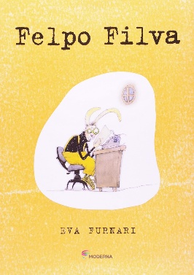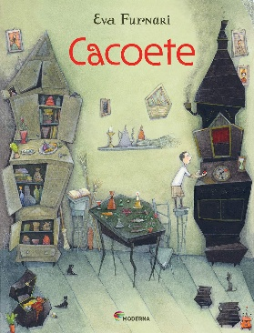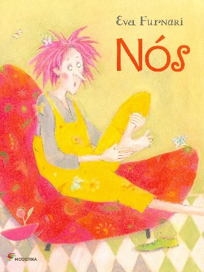
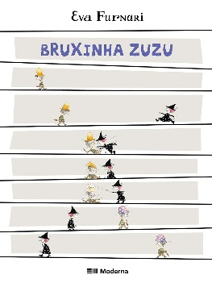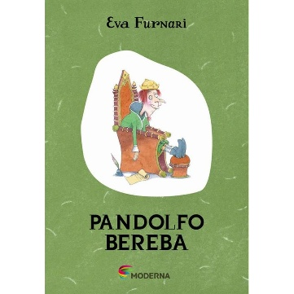
Cacoete - 02Ed. | $ 21.53
Nós | $ 21.53
Bruxinha Zuzu | $ 21.53
Pandolfo Bereba - 02Ed | $ 21.53
Felpo Filva | $ 25.74

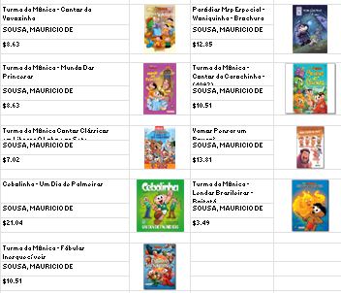
Mauricio de Sousa is a Brazilian cartoonist and publisher born in 1935 in the state of São Paulo. He began his career as a newspaper reporter before turning to comics, where he created some of the most famous fictional characters in Brazilian culture.
He is best known for creating Turma da Mônica (Monica’s Gang), a comic series featuring characters such as Mônica, Cebolinha, Cascão, and Magali. The stories combine humor, friendship, and everyday childhood experiences in a way that has connected with readers for decades. His comics grew into books, television programs, movies, educational materials, and one of the largest children’s publishing franchises in Latin America.
His work helped millions of children develop a love of reading through accessible and entertaining stories. His characters became cultural icons and introduced generations of Brazilian children to reading, comics, and national popular culture. The Turma da Monica go in and out of print. This is a sampling of the best sellers from the distributer.

