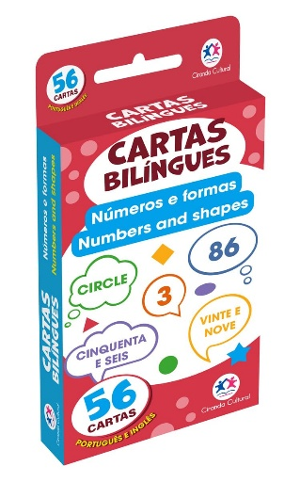
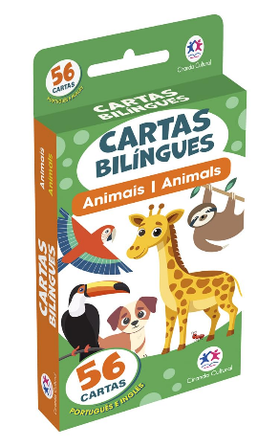
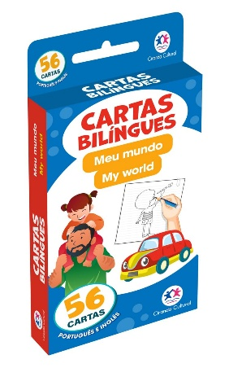
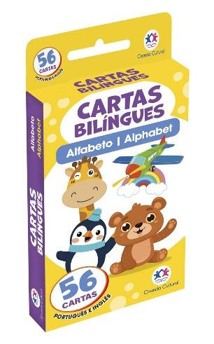
Smokley.com Bilingual Portuguese books and classroom tools

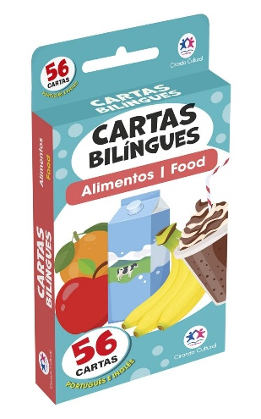
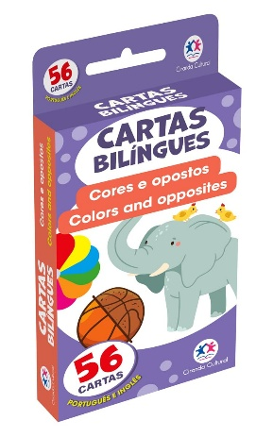
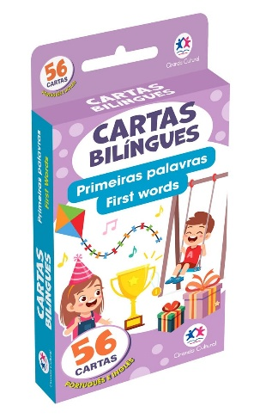
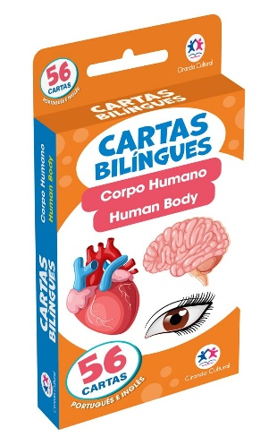

Flashcards $8.oo each. $7.00 if buying 10 or more sets
- 56 Cards in each set
- Front of card shows both English and Portuguese with an image
- Back of card has a Q-code that links to an audio of the correct pronunciation in English
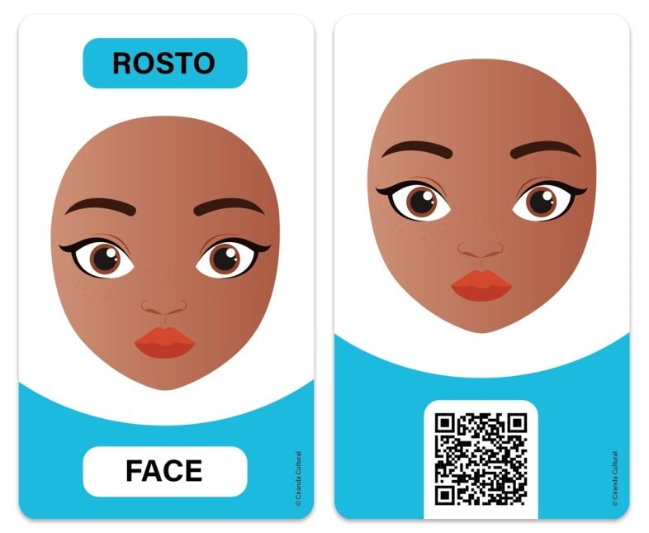•
Martha Coakley | Martha@Smokley.com | 508
-
314
-
1144

Try the Q
Code

